**UVA WELLASSA UNIVERSITY MEDICAL CENTER**

**MANAGEMENT SYSTEM**

**DIAGRAMS**

**PROJECT 01**

**CST 291-2**

**GROUP 03**

**COMPUTER SCIENCE & TECHNOLOGY**

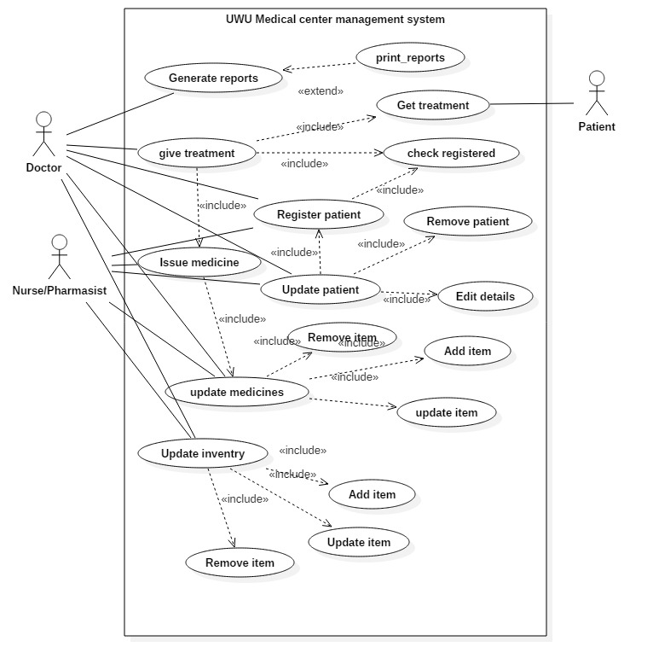**USE CASE DIAGRAM**

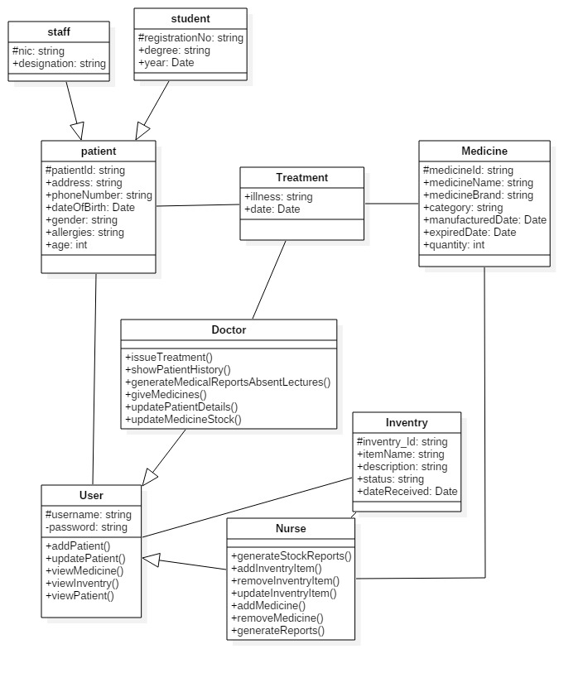**CLASS DIAGRAM**

**ER DIAGRAM**

